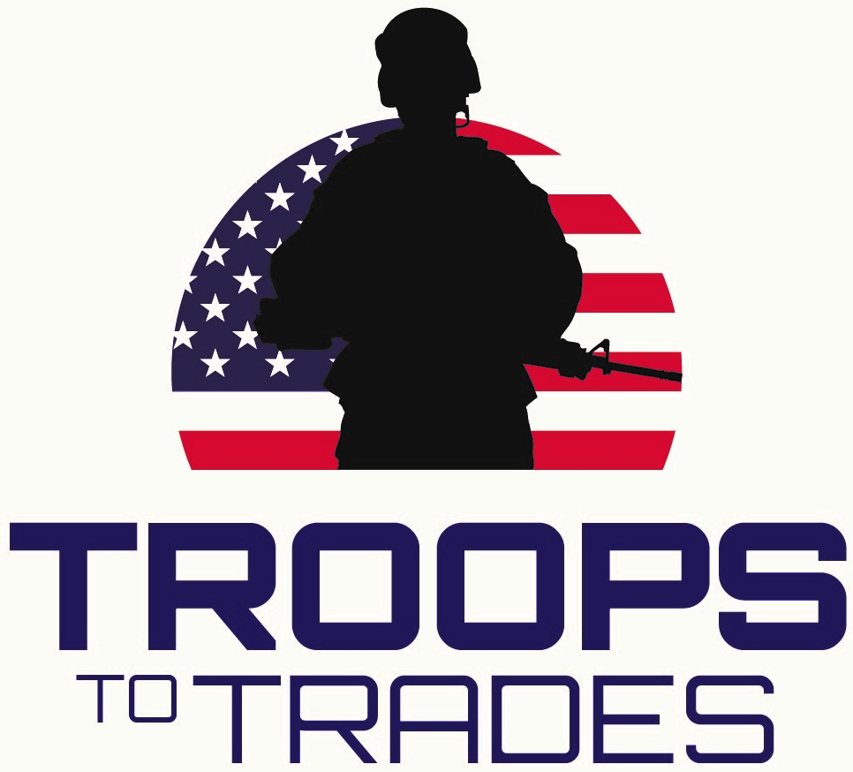

Sponsorship Letter
(DATE)
(NAME)
(COMPANY)
(ADDRESS)
(CITY, STATE, ZIP CODE)

Dear (INSERT CONTACT NAME),

HEADLINE: ABC Company Invites You to Support Military Veterans

COPY: ABC Company is hosting a golf tournament to support Troops To Trades, a program that offers scholarships and training grants to veterans, National Guard and Reserve members who are pursuing careers in the plumbing, heating and air conditioning and electrical industries. All proceeds raised during this tournament will directly benefit Troops To Trades.

Please consider supporting the (INSERT NAME OF TOURNAMENT) with a financial sponsorship, prize or in-kind services donation like food. In exchange for your donation you will have the opportunity to network with tournament golfers at the event.

We can create a customized sponsorship package for you to highlight your business that may include:

- A Presentation Speech
- Product Displays
- Sampling
- Swag Bag Inclusion
- Pre-Event Marketing
…And More!

Your tax-deductible investment shows your business’s commitment to the veterans in our community while giving you the opportunity to meet face-to-face with community leaders, golfers and military personnel.

For details on sponsorship opportunities, please contact (INSERT NAME OF TOURNAMENT DIRECTOR).

See You On The Greens!

(INSERT NAME OF TOURNAMENT DIRECTOR)
(INSERT TITLE)
(INSERT CONTACT INFORMATION)

Troops To Trades is a program powered by the Nexstar Legacy Foundation. Founded in 2005, the Nexstar Legacy Foundation is dedicated to attracting talented individuals to the heating, air conditioning, plumbing and electrical industries by inspiring these people to discover the prestige, earning power and stability of careers in these fields.

