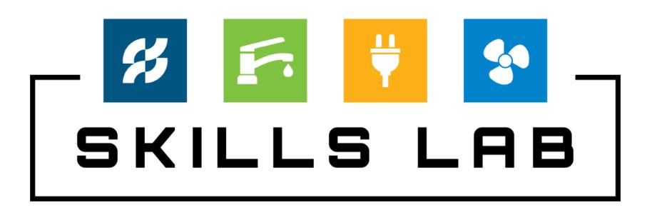
Explore The Trades Skills Lab, Built by Ferguson
Refurbished Equipment Grant Application
School Information
- Name of School:

- Address:

- Primary Contact Name:

- Primary Contact Job Title:

- Primary Contact Email:

- Primary Contact Phone number:

- Secondary Contact Name:

- Secondary Contact Job Title:

- Secondary Contact Email:

- Secondary Contact Phone Number:

- What grade levels does the school serve?

  - Middle School (grades 6-8)
  - High School (grades 9-12)

- Number of students served:

- What percentage of the student body receives free and reduced lunch?

- What is the demographic makeup of the student body?

  - Male %: _____
  - Female %: ____
  - BIPOC %: _____

- For which trade is your skills lab built?
- Plumbing
- HVAC

- How long has the class been offered to students?

- What is the curriculum for the class?

- How is this curriculum aligned with different career pathways and how are you preparing students for careers in the skilled trades? Examples could include: resume preparation, mock interviews, etc.

- How do you incorporate project-based learning into your program? Please share an example of a project that demonstrates specific skill development and problem solving.

- Describe the growth of the program (i.e. student enrollment).

- How do you measure the success of the program?

- Please briefly describe the types of repairs or new equipment that is needed.

- Is space refurbishment needed for required city and/or building code?

- What is the estimated number of students who will be impacted if the skills lab is refurbished?

- Please provide the proposed floor plan of the classroom and equipment.

- Upon receiving new equipment and/or completing space refurbishments, what is the anticipated date by which the class could be open to the student body?

Industry Partnership Information
- Does the school program work with an industry partner, or do any community partnerships exist? If so, how are industry partners, parents, administrators etc. involved?

- If so, what is the history of the partnership and how it benefits the school, the industry partner, and the community.

- What goals would the host company and school look to achieve (or have achieved) with this partnership?

- How has success been measured with this partnership?

- Did this partnership exist prior to this project?

- If this application is not selected, is it financially feasible for the class to continue?

I understand and acknowledge that the equipment will never be sold on a public site, such as Craigslist or Facebook Marketplace, or used in a personal residence or on any property outside of the school.
I confirm that all statements above are accurate and true to the best of my knowledge.
Should this application be accepted, I agree to track student participation and progress for the purpose of the grant evaluation process and potential site visits, as requested by Explore The Trades.

Signature: Date:

Explore The Trades would like to thank our program partners.


A special thank you to Ferguson,
Founding Partner of the Skills Lab program since 2021.



Partner of the Skills Lab program since 2024.

